**2024**

**SHOW PROGRAM**

**RICOCHET CIRCUS**

North end of Exhibit Pavilion

**Friday**

10:00am – 11:00am

*Have a Go Circus Workshop*

11:00am – 11:30am

*Circus Show*

1:00pm – 2:00pm

*Have a Go Circus Workshop*

2:00pm – 2:30pm

*Circus Show*

3:30pm – 4:30pm

*Have a Go Circus Workshop*

**Saturday**

9:30am – 10:30am

*Have a Go Circus Workshop*

10:30am – 11:00am

*Circus Show*

12:00pm – 1:00pm

*Have a Go Circus Workshop*

1:00pm – 1:30pm

*Circus Show*

2:30pm – 3:30pm

*Have a Go Circus Workshop*

**HOCKEY GROUND**

**FREESTYLE NOW (BMX)**

**Friday**

11:00am – 11:15AM

2:00PM – 2:15PM

3:00pm – 3:15pm

4:00pm – 4:15pm

5:00pm – 5:15pm

**Saturday**

10:00am – 10:15AM

11:00am – 11:15pm

12:00pm – 12:15pm

1:00pm – 1:15pm

2::00PM – 2:15PM

**BUSKING**

**Friday**

11:00am – 12:00pm

Kyron Smithson

12:00pm – 1:00pm

Nicholas

1:00pm – 2:00pm

Caitlyn Edwards

2:00pm – 3:00pm

Rowan Donovan

**Saturday**

10:00am – 11:00am

Talia S

11:am – 12:00pm

Nicholas

12:00pm – 1:00pm

Laura Petrie

1:00pm – 2:00pm

Mousey Stewart

**KIDS ZONE**

Court 3 Macca Stadium

**ALL DAY**

Laser Tag

Games

**EQUESTRIAN - MAIN ARENA**

**Friday from 8:00am**

Dressage

Show Jumping

Breeding

**12:00pm** Games

**1:30pm** Fashions on the Field

**3:30pm** Top Cut Out -

**(Near OLD BADMINGTON HALL)**

**Saturday from 8:00am**

Showjumping

Working Stockhorse

Lead rein/First Ridden

Ridden Horse & Pony

**12:30pm** Fancy Dress

**2:30pm** Grand Parade

**LIVESTOCK ARENA**

**Friday**

**From 9am** Sheep Judging

**From 1pm** Stud Cattle Judging

**From 10am** Junior Cattle Handlers

**Saturday**

**From 9am** Young Judges Competition

**Friday**

9.30am Poultry Judging

**KINGBROWN CAMP OVEN KITCHEN**

North end of Exhibit Pavilion

**See over for times and Menu**

**MY BEAUT UTE**

**Saturday**

9:30am Judging

2:30pm Presentations Main Arena

**FIREWORKS - MAIN ARENA**

**Friday 8:00pm**

**2024**

**SHOW PROGRAM**

**KINGBROWN CAMP OVEN KITCHEN**

**FRIDAY**

9:30am

**“How to make perfect Damper”**

A must-see masterclass for camp oven enthusiast. Tasting of hot damper with butter and golden syrup.

Plus, Kingbrowns famous bread rolls step one, mixing the batter

11:30am

**“Kingbrown delicious Cappuccino Damper”** with tastings after.

Plus, Saltbush Bill’s Corned Beef with the baked steamed technique

1:30pm

**“Fruitcup Cordial Damper with Mango and Cream”**

Plus, how to make and cook the Kingbrown’s Famous Bread Rolls.

**SATURDAY**

9:30am

**“Kingbrowns Ultimate Breakfast Damper”**

11:30am

**“The legendary Trilby Station Damper”** with Corned beef, Creamed Corn, Cheese and shallots.

1:30pm

**“Green Ginger Wine Dessert Damper”** with Pineapple, Coconut and custard.

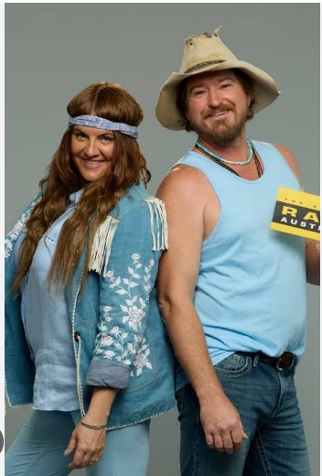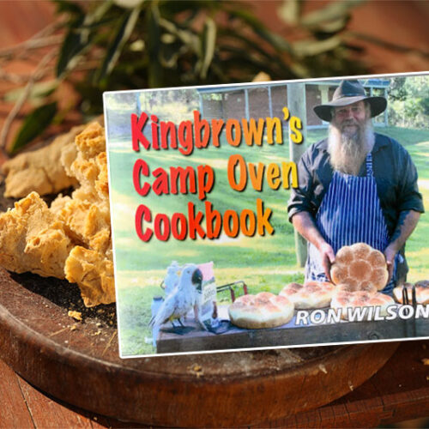

**AROUND THE GROUNDS**

**ALL DAY**

Competition Displays

Rotary Club Train

Trade Displays

Livestock

**Friday**

Esperance Brass Band

**Saturday**

Eastern Goldfields Pipe Band

2:30pm Grand Parade – Main Arena

2:00pm-4:00pm Collection of Prize Money at Show Office

3:50pm Eastern Goldfields Pipe Band – Exhibit Pavilion

4:00pm Trophy Presentation – Exhibit Pavilion

4:30pm Exhibit Pavilion Closes

**FIREWORKS - MAIN ARENA**

**Friday 8:00pm**

**BROOKE McCLYMONT**

**ADAM ECKERSLEY**

**Friday 6:30pm & 8:15pm**